Respect and Equality in TAFE Action Plan

Acknowledgements
Our Watch acknowledges the Traditional Owners of the land across Australia on which we work and live. We pay our respects to Aboriginal and Torres Strait Islander peoples past and present.
Our Watch acknowledges the support of the Victorian Government.

© Our Watch 2021

A tool to guide your TAFE’s plan to progress gender equality across the five key domains of Respect and Equality in TAFE

The Respect and Equality in TAFE Action Plan outlines the process for creating a TAFE environment where all staff and students feel safe, respected and valued. An action plan enables TAFEs to move beyond an ad-hoc (programmatic) approach to gender equality and ensures investment in gender initiatives is targeted.
Having a shared understanding of the action plan increases commitment to the initiatives and enables all parts of the institute to work together towards achieving shared objectives. The action plan provides a blueprint for accountability against measurable objectives – outlining who will execute tasks and by when.
Whilst this template provides a guide to developing an action plan, no two TAFEs are the same, and each TAFE may choose a different approach to creating a plan that meets their needs and aligns with their current context. Taking this into consideration, an effective approach to promoting gender equality should be:
- tailored to suit the individual resources, capacity and cultural needs of the TAFE
- owned and driven by the TAFE
- driven and modelled by leadership
- supported by a long-term strategy
- aligned to existing organisational policies and initiatives
- evidence based
- focused on changing organisational culture
- a process of continual improvement.
Figure 1: The five key domains of the Respect and Equality in TAFE approach
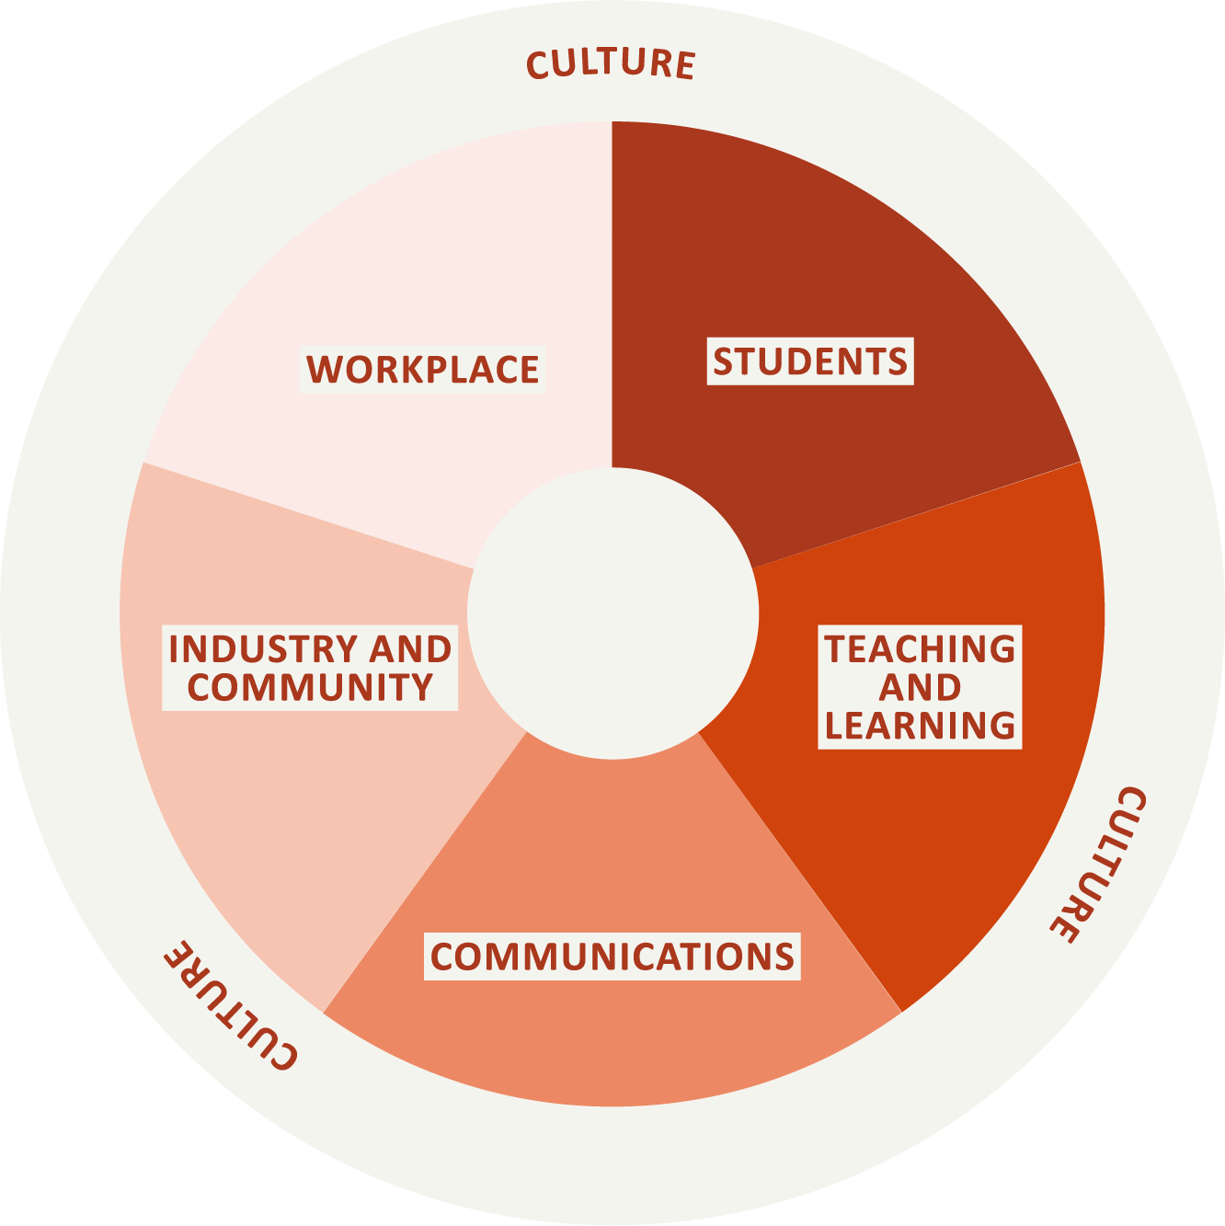
This action plan template will help you to outline tailored strategies to focus your efforts, the timeframes in which you plan to complete them and who will drive the actions.
The development of the Respect and Equality in TAFE action plan should be guided by steps 1–3 of Respect and Equality in TAFE: Building a TAFE environment that promotes gender equality and respect, including the gender audit, consultations with staff and self-assessment workshops, which would have highlighted good work already occurring across the five domains, documented the evidence of this work and illuminated further opportunities to progress gender equality.
The self-assessment process will also have identified priority areas to focus on, including those that can be achieved in the short term and those that will require a longer timeframe and greater resourcing.

Short term vs long term actions
Changing something as entrenched as gender inequality will not happen quickly or easily. It requires sustained effort to drive generational change to deeply entrenched beliefs and behaviours in our culture, society, communities and daily lives. It will not be quick, but it is possible if we all work together. TAFEs can use this organisational change process to create an environment where all people are not only safe but also respected, valued and treated as equals.
A typical Respect and Equality in TAFE action plan time frame will span between three to five years. Actions and initiatives need to be distributed over time to ensure cost-effective delivery outcomes, and time frames need to be identified for each action.

Short-term goals
If this is your institute’s first Respect and Equality in TAFE action plan, many of the actions may be focused on setting your TAFE up to succeed and achieve lasting change. The first stage of organisational change often starts with an increase in investment in gender equality, and infrastructure to support it.
Proven and promising practice from other workplace organisational change programs and gender equality programs can be scaled up and embedded into your TAFE system and institutional practices (visit the Our Watch website and the Our Watch Prevention Handbook website for further examples and resources). Members of your workforce may require training to build their understanding, and tools and resources may need to be developed.

Examples of short-term goals your TAFE may strive towards in the first 12 months of the Respect and Equality in TAFE action plan:
- Leadership commitment secured
- Establishment or review of policies and procedures to prioritise staff and student safety
- Staff and students have awareness of their TAFE’s commitment to gender equality
- A skilled prevention workforce begins to emerge, as staff and students increase their understanding of the prevention of violence against women
- Establishment of coordination, governance and quality assurance mechanisms
- Establishment of shared monitoring, accountability and reporting frameworks

Longer term goals
Once initial strategies are implemented and embedded over successive years, signs of progress will begin to emerge. You may choose to broaden your focus now that internal policies, practices and structures have been implemented, and engage with your external stakeholders to deepen this work through community engagement, and utilising new and existing partnerships.
Emerging evidence from consultation, feedback from staff and students, practice experience and monitoring should be incorporated into the continuation or discontinuation of actions, as well as inform the design of new prevention initiatives.
Coordination and governance mechanisms should be reviewed and adapted when opportunities to improve arise. TAFEs may also wish to focus on fostering and supporting the next generation of staff and student leaders in this phase.

Examples of longer-term goals your TAFE may strive towards over the course of your action plan:
- More staff and students are empowered to challenge the drivers of violence against women and promote gender equality - personally, professionally and socially
- All policies and procedures have been reviewed with a gender lens, and new initiatives take into consideration the impact on all members of the TAFE community, particularly those from marginalised groups
- New and innovative prevention activity, programs and strategies, specific to the TAFE context are implemented in different domains
- Proven initiatives are scaled up across TAFE
- Current partnerships reviewed, identifying opportunities to promote gender equality with industry partners
- Creating safe, respectful environments begins to become core business across the five domains

Assessing progress across the five domains
Wherever you enter this process, it is important to ensure the gender equality activities at your TAFE involve the entire institute and over the long term your initiatives address all five domains:
- Workplace
- Students
- Teaching and learning
- Communications
- Industry and community

Measuring progress
Some attitudes, practices and structures towards gender equality may transform quickly, whilst others may take time. Each individual, team and area of your workplace will go through different stages of change, so regular monitoring and reflecting will help make sure your actions are appropriate to support sustained change. Goals are things that we can measure and are markers of progress and impact. Indicators are necessary to help determine what data needs to be collected to assess the progress of the action plan and if it is on track to achieving its goals and objectives. Your indicators should be specific, measurable, achievable, realistic and timely.
Process indicators relate to different aspects of the process of implementation: who was ‘touched’ by the different activities (individuals, teams, students, the wider community) and the quality and appropriateness of the way activities were conducted, including their planning. It investigates the process of implementing your actions.
Process indicators for measuring progress and participation could include:
- the number of workshops delivered and number of participants in each workshop
- the rates of participation for different groups within the TAFE community
- the levels of satisfaction
- development of a Respect and Equality in TAFE Taskforce
- number of meetings held by the Respect and Equality in TAFE Taskforce
- information about Respect and Equality in TAFE is uploaded onto the TAFE website and staff intranet.
Impact indicators point to the desired changes that could be expected in individuals, teams or organisational culture by the end of the initiative or after specific activities had been completed. Impact indicators are broader and assess the overall effects.
Indicators for measuring impact could include:
- changes in individual attitudes and knowledge about gender inequality and violence against women
- increased confidence in talking about gender equality and violence against women
- increased staff understanding of the TAFEs commitment to gender equality
- changes to teaching practices and materials to promote gender equality
- increase in staff adopting flexible work practices
- external communications material (website, brochures etc) is free from gender stereotypes and have considered inclusivity and diversity
- gender equality is integrated in the selection criteria for all new tenders

Tracking progress
You will need to collect data to measure and track progress, and the impact of your activities. There are two main types of data collection: quantitative and qualitative.
Quantitative information refers to numbers or percentages. This can include the number of people who have completed surveys, attended activities, contributed to planning, responded to questionnaires or changed their readiness levels.
Qualitative information refers to opinions, views and experiences. This can include people’s stories of their experience with the initiative, views about whether they think they have more knowledge or a better understanding, reflections about whether they now think or act differently, and changes to practices across the TAFE.
Information can be collected using a range of different methods. Before you start, consider the types of data you are already collecting as a TAFE, what methods of data collection are available to you and why you want to collect certain pieces of data. Collection methods can include:
- questionnaires or surveys
- participant numbers
- diary/reflection journal
- interviews
- focus groups
- feedback forms
- observation
- documented changes to policies, curriculum resources and practices
- production of resources/documents
- documentation of the development of new initiatives and governance structures.

Respect and Equality in TAFE action plan template

Vision
A clear, agreed direction is the backbone of your action plan. A vision provides staff, students and the community with greater clarity and motivation about the need to address the gendered drivers of violence against women. A vision should clearly describe ‘where’ you want to be and ‘what’ you want to become to ensure you direct resources and focus action to achieve that desired future state.
Insert your vision for respect and equality at your TAFE

Alignment
As specified in step one of Respect and Equality in TAFE: Building a TAFE environment that promotes gender equality and respect, it is useful for the action plan to leverage off existing pieces of organisational activity and strategic directions to enhance buy in and outcomes. List any existing policies or strategies that this action plan aligns to.
For example:
The Respect and Equality in TAFE action plan has strong ties to existing organisational activities that challenge inequality and discrimination, and is aligned to our strategic direction of creating a TAFE that is innovative and enhances the social and economic futures of individuals, industry and communities. This includes alignment to our:
- Reconciliation Action Plan
- Strategic Plan
- Organisational Values: Collaboration, Integrity, Leadership, Innovation

Context
Step 2 of the Respect and Equality in TAFE approach asks TAFEs to conduct a gender equality ‘stocktake’ of your TAFE, to understand what already exists and identify where opportunities may lie for improvement. Briefly outline the sources of data that were used, the data collected and current status of gender equality at your TAFE, as well as any consultation that took place with staff.
For example:
The following data sources have been collected, and have been examined with a gender lens to inform our self-assessment and Respect and Equality in TAFE action plan.
Table 1: Example gender equality ‘stocktake’
Domain | Sources of data
Workplace | Our TAFE has the following staff policies:  - Equal Opportunity Policy  - Discrimination and Harassment Policy  - Family Violence Leave Policy  Staff employment data indicates female staff:  comprise 3/8 Directors  comprise 45% of leadership positions  are 2x more likely to be employed in short-term contract roles  are 3x more likely to be employed part-time  Links to the results of the People Matter survey
Students | Student enrolment data confirms:  - Male dominated courses such as plumbing, electrical and carpentry are heavily dominated by male students, comprising 93% of the student cohort  - Female dominated courses have an even greater contrast, with females comprising 96% of the student cohort  - 4% of the student population identified as Aboriginal or Torres Strait Islander  Link to Student code of conduct  Link to Student Ambassador Program  Student counselling is offered through student services
Teaching and learning | Consultation with teaching staff indicates:  - Students who use disrespectful language and behaviour towards teachers and other students in the classroom (in particular male students towards female students and staff) suffer few consequences.  - Educators have received limited training about gender equality and prevention of violence and how it relates to their role as trainers/assessors.  - Most course work does not incorporate materials that are gender sensitive or topics related to gender equity or the prevention of violence.
Communications | There have been efforts to increase diversity in student recruitment in male dominated courses  Links to marketing materials representing females in trades, and production of case studies from female graduates
Industry and partnerships | The Horticultural Cadetship program developed and implemented in partnership with local industry providers, has a key focus on increasing representation of female students in this program

Self-assessment
Step 3 of Respect and Equality in TAFE: Building a TAFE environment that promotes gender equality and respect is completion of the self-assessment. The Respect and Equality in TAFE Self-assessment tool guides you through this process including setting up assessment workshops and conducting the self-assessment. Briefly outline the self-assessment process you undertook, including, who was involved and how it was conducted. See sample plan for examples:
- The Respect and Equality in TAFE Taskforce met and conducted self-assessment workshops over 2x2 hour sessions
- The self-assessment was conducted by a health promotion officer with expertise in gender equality from an external organisation
- The development of this Respect and Equality in TAFE action plan is informed by self-assessment process, consultation with staff and the above existing pieces of organisational data

Results of the self-assessment workshops
In the below tables, insert the outcomes of your self-assessment workshops across each of the five domains. The ‘Actions for improvement’ which were identified through the self-assessment workshops for each domain can be transferred into the ‘Action for improvement’ section of the Respect and Equality in TAFE action plan.

Domain 1: Workplace
Our workplace prioritises gender equality and all staff are supported to be safe, respected and have equal opportunities at work.
Score key: 1 – Yet to address, 2 – Some work completed in this area, 3 – Fully achieved
Table 2: Outcomes of the self-assessment under the workplace domain
Goal | Score | What we are already doing | Actions for improvement
  - Our TAFE leadership demonstrates proactive commitment to gender equality and preventing violence against women.
  - Our strategies, policies and procedures include proactive measures to address gender inequality and violence against women.
  - We have structural support for women’s leadership, including the provision of leadership and promotional opportunities for part-time staff.
  - We have dedicated resources and budget to actively promote and monitor actions to prevent violence and address gender inequality, and to support those who disclose violence within our educational institute.
  - Staff across our TAFE understand the importance of promoting gender equality and feel confident and supported to challenge sexism and raise concerns related to gender and discrimination.

Domain 2: Students
All students feel safe and confident to express themselves and participate equally within our TAFE community, and can raise concerns about gender inequality, violence and discrimination without adverse consequences.
Score key: 1 – Yet to address, 2 – Some work completed in this area, 3 – Fully achieved
Table 3: Outcomes of the self-assessment under the students domain
Goal | Score | What we are already doing | Actions for improvement
  - Our engagement with students reflects our commitment to promoting gender equality and the prevention of violence against women.
  - Our policies and procedures for students are fair and inclusive and include proactive measures to address gender inequality and violence against women.
  - Our programs and services delivered to students aim to address inequality and prevent violence against women.

Domain 3: Teaching and learning
Our educators are leaders in integrating and promoting gender equality messages and actions into their teaching practice, and in creating equal and respectful learning environments.
Score key: 1 – Yet to address, 2 – Some work completed in this area, 3 – Fully achieved
Table 4: Outcomes of the self-assessment under the teaching and learning domain
Goal | Score | What we are already doing | Actions for improvement
  - Gender equality and the prevention of violence against women is embedded into our teaching practices and learning environments.
  - The skills and knowledge required to promote gender equality and prevent violence against women in different occupations is embedded into our curriculum.
  - Practical placements and apprenticeships are managed in a way that aims to overcome gender-based inequities and actively challenge stereotypes, to contribute to desegregating the workforce.
  - All teaching and learning staff feel confident and prepared to integrate evidence-based gender equality messages and actions into their teaching practice.

Domain 4: Communication
Our internal and external communications play an important role in creating an equal, safe and respectful TAFE community and culture.
Score key: 1 – Yet to address, 2 – Some work completed in this area, 3 – Fully achieved
Table 5: Outcomes of the self-assessment under the communication domain
Goal | Score | What we are already doing | Actions for improvement
  - We strive to be a public champion for gender equality and the prevention of violence against women.
  - Our internal workplace culture and communication promotes gender equality for all staff, students, industry partners and the community.
  - All external communication materials reflect our commitment to gender equality and preventing violence against women.

Domain 5: Industry and community
As a learning institute with a strong connection to industry and community, our commitment to gender equality and the prevention of violence against women is reflected in all that we do.
Score key: 1 – Yet to address, 2 – Some work completed in this area, 3 – Fully achieved
Table 6: Outcomes of the self-assessment under the industry and community domain
Goal | Score | What we are already doing | Actions for improvement
  - We use our public profile, influence and strong connection to community to act as leaders in gender equality and the prevention of violence against women.
  - We partner with industry in a strategic and meaningful way that actively promotes gender equality and the prevention of violence against women.
  - We engage with our broader TAFE community to promote gender equality and prevention of violence against women.
  - Our engagement with students, staff, industry partners and the community reflect our commitment to promoting gender equality and the prevention of violence against women.

Action plan

Domain 1: Workplace
Our workplace prioritises gender equality and all staff are supported to be safe, respected and have equal opportunities at work.
Table 7: Actions under the workplace domain
Goal | Action | Responsibility | How it will be achieved | Timeframe | Indicators
  - Our TAFE leadership demonstrates proactive commitment to gender equality and preventing violence against women.
  - Our strategies, policies and procedures include proactive measures to address gender inequality and violence against women.
  - We have structural support for women’s leadership, including the provision of leadership and promotional opportunities for part-time staff.
  - We have dedicated resources and budget to actively promote and monitor actions to prevent violence and address gender inequality, and to support those who disclose violence within our educational institute.
  - Staff across our TAFE understand the importance of promoting gender equality and feel confident and supported to challenge sexism and raise concerns related to gender and discrimination.

Domain 2: Students
All students feel safe and confident to express themselves and participate equally within our TAFE community, and can raise concerns about gender inequality, violence and discrimination without adverse consequences.
Table 8: Actions under the students domain
Goal | Action | Responsibility | How it will be achieved | Timeframe | Indicators
  - Our engagement with students reflects our commitment to promoting gender equality and the prevention of violence against women.
  - Our policies and procedures for students are fair and inclusive and include proactive measures to address gender inequality and violence against women.
  - Our programs and services delivered to students aim to address inequality and prevent violence against women.

Domain 3: Teaching and learning
Our educators are leaders in integrating and promoting gender equality messages and actions into their teaching practice, and in creating equal and respectful learning environments.
Table 9: Actions under the teaching and learning domain
Goal | Action | Responsibility | How it will be achieved | Timeframe | Indicators
  - Gender equality and the prevention of violence against women is embedded into our teaching practices and learning environments.
  - The skills and knowledge required to promote gender equality and prevent violence against women in different occupations is embedded into our curriculum.
  - Practical placements and apprenticeships are managed in a way that aims to overcome gender-based inequities and actively challenge stereotypes, to contribute to desegregating the workforce.
  - All teaching and learning staff feel confident and prepared to integrate evidence-based gender equality messages and actions into their teaching practice.

Domain 4: Communication
Our internal and external communications play an important role in creating an equal, safe and respectful TAFE community and culture.
Table 10: Actions under the communication domain
Goal | Action | Responsibility | How it will be achieved | Timeframe | Indicators
  - We strive to be a public champion for gender equality and the prevention of violence against women.
  - Our internal workplace culture and communication promotes gender equality for all staff, students, industry partners and the community.
  - All external communication materials reflect our commitment to gender equality and preventing violence against women.

Domain 5: Industry and community
As a learning institute with a strong connection to industry and community, our commitment to gender equality and the prevention of violence against women is reflected in all that we do.
Table 11: Actions under the industry and community domain
Goal | Action | Responsibility | How it will be achieved | Timeframe | Indicators
  - We use our public profile, influence and strong connection to community to act as leaders in gender equality and the prevention of violence against women.
  - We partner with industry in a strategic and meaningful way that actively promotes gender equality and the prevention of violence against women.
  - We engage with our broader TAFE community to promote gender equality and prevention of violence against women.
  - Our engagement with students, staff, industry partners and the community reflect our commitment to promoting gender equality and the prevention of violence against women.

