Monitoring guide

Acknowledgements
Our Watch acknowledges the Traditional Owners of the land across Australia on which we work and live. We pay our respects to Aboriginal and Torres Strait Islander peoples past and present.
Our Watch acknowledges the support of the Victorian Government.

© Our Watch 2021

Introduction
This guide has been developed to support monitoring, reflection and learning on action to promote respect and equality in your TAFE. The action you take will be informed by the process outlined in Respect and Equality in TAFE: Building a TAFE environment that promotes gender equality and respect and detailed in your Respect and Equality in TAFE action plan. This guide aims to support the ongoing refinement of action plans and to ensure that activities are adapted and prioritised as your TAFE context changes. The purpose is to encourage critical reflection on what should come next, based on the information available.

Why is monitoring important?

No two TAFEs are the same, so the actions you take to promote gender equality and prevent violence against women will be tailored to suit the available resources, capacity and cultural needs of your TAFE.
Some attitudes, practices and structures towards gender equality may transform quickly, whilst others may transform at a slower pace and take time. Each individual, team and area of your workplace will go through different stages of change, so regular monitoring and reflection will help make sure your action plans are appropriate to support sustained change.
Over time, monitoring and reflection will help you to identify and refine actions to support Respect and Equality in TAFE activities across the five domains:
- workplace
- students
- teaching and learning
- communications
- industry and community.

Figure 1: The five key domains of the Respect and Equality in TAFE approach
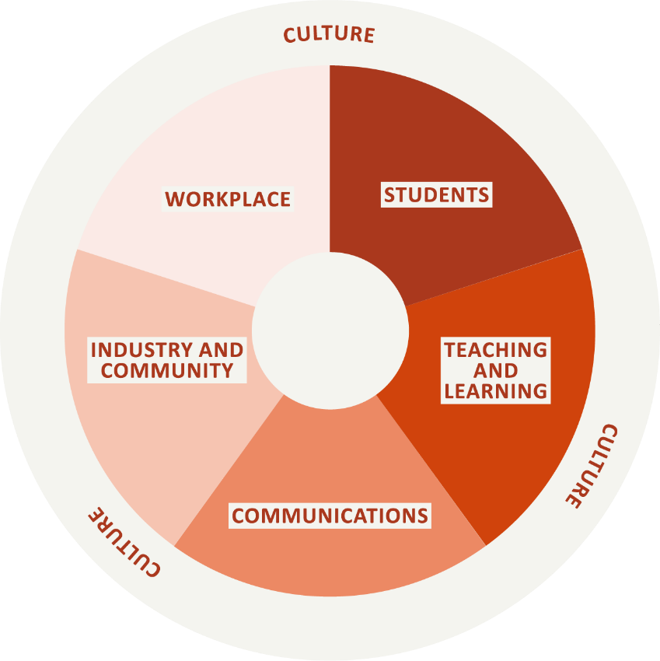

The planning and reflection cycle
As outlined in Steps 2 to 4 of the Respect and Equality in TAFE: Building a TAFE environment that promotes gender equality and respect, it is important to gather data and engage with key staff so that when you develop your action plan it is tailored to your specific TAFE’s needs and resources. It is up to you how often you review your action plan – you may do it in one-, two- or three-year cycles. With each cycle, you should stop to reflect on your progress within your chosen actions and to revise your action plan. This process is outlined in Figure 2 below.
Figure 2: The planning and reflection process
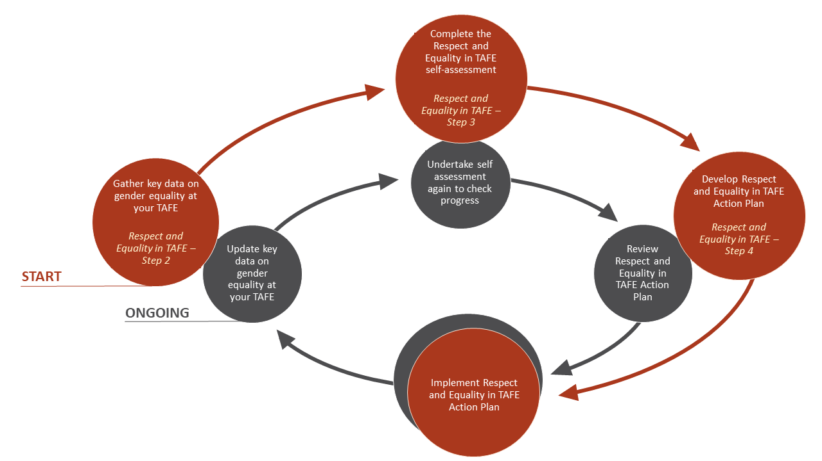
As shown in Figure 2, every time you want to review your action plan, it is important to understand how effective your actions have been and what changes have occurred in your TAFE. The key steps to help monitor your progress and review your action plan will mirror those taken to develop your first action plan:
- step 2 – update key data on gender equality in TAFE
- step 3 – undertake self-assessment again to check progress
- step 4 – review Respect and Equality in TAFE action plan.
This guide will help you consider what information will be useful to gather at each of the review steps and demonstrates how you can use the action plan template to ensure you are collecting appropriate monitoring data.
When reviewing your action plan, it is useful to revisit Change the story: A shared framework for the primary prevention of violence against women and their children in Australia. This framework outlines four expressions of gender inequality (called ‘gendered drivers’) that consistently predict higher rates of violence against women in a society:
- The condoning of violence against women (e.g., excusing or trivialising violence, victim blaming)
- Men’s control of decision making and limits to women’s independence (e.g., attitudes that men should be in charge and make better leaders than women)
- Stereotyped constructions of masculinity and femininity (e.g., the notion that men should be strong, and women should be caring)
- Male peer relations that emphasise disrespect and aggression towards women (e.g., locker room talk)
While not all initiatives will seek to change every driver outlined in Change the story or Changing the picture: A national resource to support the prevention of violence against Aboriginal and Torres Strait Islander women and their children, it is crucial that any review investigates whether and how an initiative engages with and contributes to shifting the intersecting drivers targeted by an initiative.

Planning for monitoring and reflection

Considerations before you begin
To support monitoring and reflection you should consider the following questions from the start:
- Who is responsible for leading the monitoring?
  - The review and reflection process should only be undertaken if there is a genuine commitment to implementing and updating the action plan. The gender equality lead (described in Respect and Equality in TAFE: Building a TAFE environment that promotes gender equality and respect, may be best placed to lead monitoring, but they cannot do it alone. They should seek to engage with members of the Respect and Equality in TAFE Taskforce (see Step 1 of Respect and Equality in TAFE: Building a TAFE environment that promotes gender equality and respect and draw on other expertise that exists in your TAFE. If you have staff in your TAFE with expertise in monitoring and tracking change, whether they be educators or administration staff, engage them in this process.
  - How often will you review your action plan? Your action plan timeframes will typically span anywhere from 1 to 5 years with individual actions accorded their own timeframe e.g., ‘Our leadership group demonstrates a commitment to gender equality and prevention of violence against women through the issuing of a public commitment in all TAFE communications to staff and students’, might have a timeframe of 12 months. Whereas reviewing policies and procedures with a gender lens may have a timeframe of 2 years. Employing a cyclic review and monitoring process including self-assessments will allow you to monitor your action plan regularly. It is a good idea to align and incorporate your review of your action plan to existing planning and reporting cycles such as those for your operating or strategic plans.
- How will you involve stakeholders in reflecting on and learning from progress against your Respect and Equality in TAFE action plan?
  - Taskforce members have a significant role in reviewing the action plan, but they are not the only people to involve. It is important to identify key stakeholders within your TAFE who can bring a wealth of insight and expertise across the five domains. Reflect on the characteristics of your staff and student populations and be conscious of the fact that people experience different forms of power, privilege and oppression, based on their identity and social status. Women do not only experience sexism. Women may also experience racism, classism, ableism, heterosexism, colonialism, ageism and more. These multiple forms of discrimination interact and intersect, so there are not only inequalities between women, men and gender diverse people, but also inequalities between groups of women.
  - Think about the action plan goals and ask yourself, who in TAFE can offer insights into whether the particular goal has been achieved or what may be the barriers to its achievement? For example, if you have a goal of ‘we have structural support for women’s leadership, including the provision of leadership and promotional opportunities for part-time staff’, the stakeholders in this case would be women who work part-time, recognising that this group is not homogenous. You want to gather the diverse perspectives of your staff population which means involving casual educators, women in various positions and levels of authority, Aboriginal and Torres Strait Islander staff, women staff members with carer responsibilities etc. The broader the representation of women you involve in the monitoring and reflection, the greater the richness of the insights you will gather.

Types of data collection
You will need to collect data to measure and track progress, and the impact of your activities. There are two main types of data collection: quantitative and qualitative.
Quantitative information refers to numbers or percentages. This can include the number of people who have completed surveys, attended activities, contributed to planning, responded to questionnaires.
Qualitative information refers to opinions, views and experiences. This can include people’s stories of their experience with the initiative, views about whether they think they have more knowledge or a better understanding, reflections about whether they now think or act differently, and changes to practices across the TAFE.
Information can be collected using a range of different methods. Consider the types of data you are already collecting as a TAFE, what methods of data collection are available to you and why you want to collect certain pieces of data. Collection methods can include:
- questionnaires or surveys
- in-depth interviews
- focus group discussions
- observation
- secondary data (e.g., documented changes to policies, curriculum resources and practices, production of resources/documents, documentation of the development of new initiatives and governance structures, diary/reflection journal).

Ensuring safety when consulting staff and students
Consultation with staff and students can be great opportunities to increase understanding of gender equality and prevention of violence against women and to learn about how effective your action plan is. However, while conversations about gender equality and violence are necessary and useful, they can be uncomfortable and bring up sensitive issues. It is important to make sure that anyone gathering information is equipped to:
- appropriately respond to any disclosures of violence
- assist a person to access the appropriate supports within your TAFE and/or the broader community
- answer common questions and concerns that arise.
It is also vital that confidentiality is considered and safe and supportive opportunities for people to speak frankly are provided.
You should make sure that anyone gathering information, has the backing of the leadership group and is provided with opportunities to debrief.

Identifying data to collect
Before you implement your action plan, identify what data you will collect to support monitoring and reflection and note it in the action plan table.
Table 1: Example of monitoring data you could collect against example actions
Goal (from self-assessment) | Example action | Responsibility | How it will be achieved | Time  frame | Monitoring data
1.1 Our TAFE leadership demonstrates proactive commitment to gender equality and preventing violence against women. | Leadership group to develop and communicate a statement clearly articulating TAFE’s commitment to gender equality and expectations of all staff to promote gender equality | With coordination support from the gender equality lead.  Senior leadership group  Managers | Senior leadership group dedicate time to creating a leadership statement at the executive meeting  Leadership group statement is published on the staff intranet and student facing website  Leadership group statement is shared via email to staff and students  Leadership group statement and expectations of staff are discussed at team and staff meetings | 3 months | Minutes from team and staff meetings discussing the statement  Leadership group statement published on the staff intranet and student facing websites  Staff have knowledge of the leadership group statement  Staff are aware of expected behaviour to promote gender equality  All members of the leadership group can confidently explain and communicate the statement
2.1 Our engagement with students reflects our commitment to promoting gender equality and the prevention of violence against women. | Enable student engagement by involving students in promoting gender equality and the prevention of violence against women. | With coordination support from the gender equality lead.  Senior leadership group  Managers, Student Services and Communications | Our communication with students consistently and deliberately promotes gender equality.  We regularly review our student engagement practices, including the language and imagery used, to ensure they do not reinforce harmful gender and other stereotypes.  We value student expertise and engage them in the co-design of TAFE gender-based violence prevention activities such as:  - Engaging students in planning and working groups for gender equality and violence prevention activities  - Seeking student input when reviewing student-facing policies and procedures. | 12 months | Feedback from students  Students are engaged in reviewing gender equality messages  Students are engaged in co-design of prevention activities
3.4 All teaching and learning staff feel confident and prepared to integrate evidence-based gender equality messages and actions into their teaching practice. | Provide professional development opportunities for educators to explore how to apply a gender lens to their teaching practices. | With coordination support from the gender equality lead.  Education leaders, teaching and learning staff | We have a professional learning strategy for educators, assessors and practical placement and apprentice co-ordinators that builds their knowledge and capacity to understand key evidence-based concepts including respectful relationships, gender, gender lens, gender equality and the drivers of violence against women.  Our professional learning strategy ensures all educators, assessors and practical placement and apprentice co-ordinators (both permanent and casual staff) have equitable access to, and opportunities to participate equally in, all professional development opportunities. | 3 years | Educators have the knowledge, skills, confidence and support to call out sexism and discrimination when they see it.  Educators have the knowledge, skills and training to identify and respond appropriately to students who may be experiencing or perpetrating violence against women.  Training is provided to educators on gender equality and responding to disclosure of violence within your TAFE.  Staff comply with our relevant state or territory mandatory reporting and child safety laws, including the completion of annual training or professional development.
4.3 All external  communication materials reflect our commitment to gender equality and preventing violence against women | Review and update your communications strategy to promote gender equality and the prevention of violence against women. | With coordination support from the gender equality lead.  Marketing and Communications Manager | We have a communications plan for students and external stakeholders that outlines a process for sharing information and resources to build their understanding of gender equality and address the drivers of violence against women.  Our digital marketing and advertising strategy for student recruitment seeks to overcome gender imbalances across industries by promoting all courses in a way that challenges gender stereotypes. | 12 months | Our communication and marketing strategies are reviewed from a gender equality perspective, including internal and external marketing and advertising, style guides, and inclusive language guides.  Our communications materials are reviewed to ensure they promote gender equality and challenge gender and other stereotypes, and are representative of the diversity of our communities. This includes our website, newsletter, online platforms, recruitment materials, student orientation, enrolment and information and engagement materials.
5.2 We partner with industry in a strategic and meaningful way that actively promotes gender equality and the prevention of violence  against women. | Create opportunities for industry and partners to get involved in addressing gender inequality in their own work environments. | With coordination support from the gender equality lead.  Leadership group  Practical placement and apprenticeship co-ordinators | Our board and leadership group actively engage with industry partners to identify opportunities to contribute to improving gender equality within industry through student education and training and preparing future workforces to prevent violence against women.  We support and create opportunities for industry partners to get involved in addressing gender inequality through participating in the Respect and Equality in TAFE approach, as well as in their own work environments.  We support industry to recruit, support and welcome men, women and gender diverse student placements and apprenticeships in traditional gender segregated workplaces. | 3 years | Industry partners are engaged by TAFE leadership group in educating and training and preparing future workforce to promote gender equality  Industry partners get involved in addressing gender inequality in TAFE and their own work.  Industry partners are supported to recruit, and welcome women, men and gender diverse student placements and apprenticeships in traditional gender segregated workplaces.  Criteria for gender equality and prevention of violence against women are built into procurement tendering or competitive bidding processes.

Ongoing monitoring of your action plan

Step 1: Update key data on gender equality in TAFE
Before you develop your first action plan, you should undertake a gender equality ‘stocktake’. This will include collecting and reviewing data about gender equality within your TAFE. As shown in Step 2 of Respect and Equality in TAFE: Building a TAFE environment that promotes gender equality and respect this may include data on things like:
- ratio of men to women in leadership and management positions
- changes in staff perception of workplace culture as measured by annual staff surveys
- the percentage of male, female and gender diverse students, overall and by course enrolment and completion
- student perceptions of TAFE culture as measured by annual surveys such as ‘student experience surveys’, if available*
- student perceptions on educators applying a gendered lens to their teaching practices*
*When undertaking any surveys or consultations with staff or students, expert advice should be sought to ensure data is requested and collected safely and adequate processes are in place to respond appropriately to any disclosures of experiencing violence or harassment and data is sought, managed and stored in line with privacy and data protection obligations.
When you review your action plan, you should revisit this ‘stocktake’ and update data to ensure you are tracking what may have changed over time. This is likely to require a desktop review of policies and procedures as well as consultation with key Human Resources, data custodians and Student Services staff.

Step 2: Undertake self-assessment again to check progress
When you commence work on Respect and Equality in TAFE, you will also be asked to undertake a self-assessment on your TAFE. It is useful to undertake a self-assessment again when you review your action plan. Depending on the length of your review cycle (one, two or three years) you may decide to undertake a full self-assessment again or to only assess your TAFE against the domains that you prioritised or focused on for your action plan.

Step 3: Review your Respect and Equality in TAFE action plan
Once you have updated key data on gender equality in your TAFE and you have undertaken the self-assessment you can review your action plan. Some guiding question that may be useful to help you reflect on progress include:
- Progress or achievements of (specific indicators/goals/domains) of the unit/group?
- What worked and what didn’t work? Why?
- What factors helped to make actions successful or effective? How can we build on these?
- What factors worked as barriers to change? How can we address these?
- Who was engaged? Who was not? Why? How can we make sure the actions we take are accessible and appropriate for all staff and/or students?
- What lessons have we learned?
- What have we learned from other TAFEs that we can apply in our TAFE?
As you choose actions to amplify strengths or address challenges, remember that attitudes, practices and structures towards gender equality take time to transform so actions may need to build over time to create change.

Evaluation
Evaluating the impact of primary prevention initiatives in the TAFE setting requires more in-depth activities that would build on the monitoring processes described in this guide.

Evaluation aims to assess the overall impact of a social change intervention against an explicit set of goals and objectives. Evaluation involves the systematic collection and analysis of data to help us discover if, how, and why a particular intervention or set of interventions worked or did not…Evaluations can be conducted before (formative), during (developmental), and after (summative) an intervention is implemented for the purposes of program, project, or policy improvement, knowledge building, or learning.
Association for Women’s Rights in Development (AWID), 2010
It is likely that TAFEs will need the support of experts if they choose to undertake an evaluation of particular initiatives or their whole of TAFE approach. These resources can support those seeking to better understand quality approaches to the evaluation of primary prevention initiatives:
Evaluating Victorian projects for the primary prevention of violence against women: A concise guide
Evaluating preventing violence against women initiatives: A participatory and learning-oriented approach for primary prevention in Victoria
Preventing violence against women. Doing evaluation differently: A five step guide for funders, evaluators and partners to build capacity for evaluation, learning and improvement
Section 9: Evaluating your work and building the evidence for prevention in Putting the prevention of violence against women in practice: How to change the story
Evaluation quick guides

Association for Women’s Rights in Development (AWID), Capturing Change in Women’s Realities A Critical Overview of Current Monitoring & Evaluation Frameworks and Approaches 2010

