Case study: Chisholm Institute women in trades partnership

Domain: Industry and Community

This case study is an example of activity under the Industry and Community domain of Respect and Equality in TAFE: Building a TAFE environment that promotes gender equality and respect.

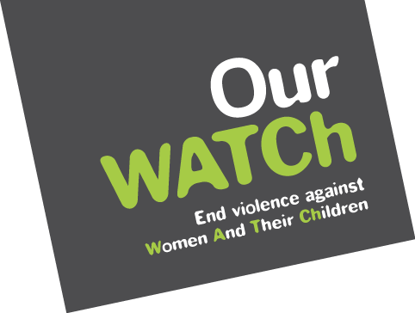
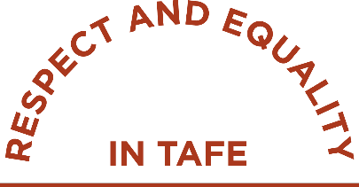
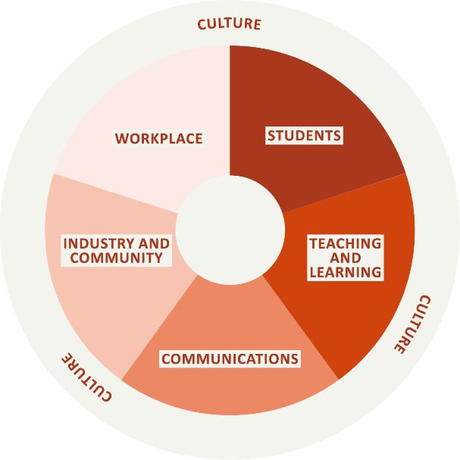

Acknowledgements
Our Watch acknowledges the Traditional Owners of the land across Australia on which we work and live. We pay our respects to Aboriginal and Torres Strait Islander peoples past and present.
Our Watch acknowledges the support of the Victorian Government.

© Our Watch 2021

Who was involved?
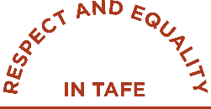
Chisholm Institute (Chisholm) is one of Victoria’s public entities providing vocational education and training, funded by the Victorian Government, located in Melbourne’s south-east. Chisholm is a government-owned TAFE that offers over 300 certificate, diploma, advanced diploma, bachelor and graduate certificate courses.
Tradeswomen Australia is a not-for-profit organisation that brings industry and tradespeople together to create awareness and support for women working in male-dominated trade industries. Their goal is to increase female participation in trades to ensure true diversity, inclusiveness and equity are achieved.
Women’s Health in the South East (WHISE) is the regional women’s health service for the Southern Metropolitan Region. WHISE is a not-for-profit organisation that works to improve the health and well-being of women in the region by providing health information and education to governments, organisations, education providers, and community groups.
The Family Violence Prevention Activities in Tertiary Education Settings Pilot Project, funded by the Victorian Government’s Office for Family Violence Prevention and Coordination, which enabled four Victorian TAFEs to employ a prevention officer to be actively engaged with the primary prevention of all forms of violence against women. Chisholm was one of the TAFEs to receive this funding.

Why was the partnership needed?
The Family Violence Prevention Officer embedded at Chisholm, in collaboration with the other funded prevention officers, identified a range of activities to address violence against women across the TAFE network. Through discussions within the network, a clear opportunity emerged to better coordinate activities so that TAFEs could work together to boost awareness and strengthen the impact of gender inequality actions. Collaboration would also support establishing a long-term vision for the sector.
The Family Violence Prevention Officer initially focussed on delivering presentations to staff, with the aim of raising awareness about the prevention of violence against women, as well as the important role that TAFE can play in addressing gender inequality and the prevention of violence against women.
These presentations provided an opportunity for the Family Violence Prevention Officer to begin conversations with staff, creating an environment for staff to disclose their experiences of gender equality and share how gender inequality manifests in their department. Engaging with the Apprenticeship Support Officers highlighted the work being done at Chisholm Institute to support the mental health of trade students by focussing on suicide prevention, such as ‘R U OK? Day’ activities, aimed to create an inclusive and supportive environment for all trade students.
The Family Violence Prevention Officer attended and started conversations about respect and what respect means to each individual. These activities provided an opportunity to hear from both staff and students about their experiences of pressure to conform to gender stereotypes, and the impact this has on their daily lives. Student open days also served as an opportunity for the Family Violence Prevention Officer to talk with students and hear their experiences of gender stereotypes.
A literature review was completed to complement the anecdotal data and evidence gathered from conversations and overall engagement. This review highlighted the issues at a sector level, and then explored what could be done by TAFE to address the issues. These projects elicited a clearer understanding of the concerns of staff and students about gender inequality at Chisholm and within the trades industry. Understanding the concerns provided an opportunity to explore strategies for improvement.
The anecdotal data and literature review, combined with the student enrolment data and staff employment data, highlighted the following:
- Only 2–3% of students studying trade courses at Chisholm were female.
- Sexism and gender stereotypes were heavily present in trade courses and trade industries and were having a detrimental impact on male and female students.
- It was common for female students in trade courses to leave before completion. (Sexism was often noted as a key factor in their departure.)
- Female trade educators had reported experiencing sexism from students and colleagues.
- There is a high suicide rate by males in the trade industry (MensLine Australia), in part driven by adherence to rigid male stereotypes.
While Chisholm was working to attract more female students into its trades courses, a broader project was required to challenge the culture in which sexism was occurring. Through their partnership with WHISE, Chisholm was able to connect with Tradeswomen Australia, and the three organisations – Chisholm Institute, WHISE and Tradeswomen Australia – formed a partnership to develop strategies to challenge sexism in trades.

What were the objectives?
TAFE is an ideal setting to influence the future trades workforce, to promote gender equality and to address the current situation of few women in the industry.
The partnership aimed to achieve the following objectives:
- Increase the female student population in trade courses at Chisholm.
- Retain female students who enrol in trade courses at Chisholm.
- Create a culture in the trades department at Chisholm where all students of any gender feel safe, accepted and respected.
- Challenge the traditional gender stereotypes associated with the trade industry.
- Build trade educators’ understanding of how to create an inclusive learning environment and support them to challenge gender stereotypes and sexism in the classroom.

What has the partnership achieved?
A business case was developed by WHISE and supported by both the Family Violence Prevention Officer and Tradeswomen Australia. This business case highlighted student enrolment and retention rates, current inequalities in the trades industry (including sexism and harassment), recommendations for action and the value of these actions for Chisholm.
This business case was presented to board members, executives and key staff in the trades school. Following these presentations, the partnership between Chisholm, Tradeswomen Australia and WHISE was given permission to establish an Equity in Trade working group, comprising membership from the three organisations and internal staff at Chisholm, including executives from the trades area.
The group developed an Equity in Trade strategy to be delivered over a 2–3-year period. It aimed to address systemic barriers to attracting and retaining more women into trade. The strategy focused on the key point of entry into the workforce: trade training.
This strategy was socialised with the CEO and other senior executives. Engaging with senior leaders through this method served as a capacity-building process, and resulted in senior leaders increasing their knowledge and understanding of gender stereotypes and sexism in trade. This supported their increased commitment and buy-in to the strategy.
Tradeswomen Australia delivered a webinar in 2020 to test the trade educators’ receptivity to promoting gender equality in their classroom. The webinar was uploaded to the staff intranet for trade staff to view at a later date.
Trade educators and senior trade executives also attended a tailored workshop delivered by Tradeswomen Australia and WHISE. The workshop explored the following topics:
- everyday sexism
- research on the negative impacts of the pressures to confirm to traditional male stereotypes (based on data from ‘The Man Box’, Jesuit Social Services)
- unconscious bias
- how to address gender stereotypes and take bystander action as an educator when you hear or see sexism in the classroom.
The targeted workshops were professional development opportunities for educators to create inclusive learning environments for their students. Executive staff in trade courses encouraged teaching staff members to attend. The Equity in Trade working group created a business case highlighting the learning outcomes of the skill-building workshop and submitted this to the Professional Educators College (PEC). PEC approved the submission, and awarded attendance at the training three points towards their members’ professional development, recognising that it helped maintain educators’ knowledge of current societal expectations.

What’s next?
Tradeswomen Australia and WHISE will continue to deliver workshops to trade educators at Chisholm, with two more rounds of training to occur in 2021. Chisholm, by working with PEC, is hoping to expand beyond engaging only Chisholm educators. PEC will trial the offering of the tailored training for trades educators outside Chisholm, and if successful will continue to offer the workshop on an ongoing basis for all trades educators to enhance their skills in creating inclusive and respectful learning environments.
The future ambition of the partnership between Chisholm, WHISE and Tradeswomen Australia is to work with employers and apprenticeship providers to build their capacity to provide an environment which is safe, inclusive and respectful for apprentices of all genders.

What were the benefits?
- Tradeswomen Australia and WHISE were able to provide subject matter expertise and impart this knowledge to staff. Tradeswomen Australia know the language, practices and realities of the trades industry, and can both provide evidence and share lived experience of what it is like as a female studying and working in a trade. WHISE are experts in the prevention of violence against women, and were able to share research relating to gender stereotypes and evidence of gender inequality in Australia.
- With Tradeswomen Australia and WHISE providing the subject matter expertise, the Family Violence Prevention Officer coordinated the workshops and facilitated the engagement of Tradeswomen Australia and WHISE to Chisholm’s trade educators.
- Establishing the Equity in Trade working group has resulted in the formation of sustainable relationships between Chisholm, WHISE and Tradeswomen Australia. These relationships—and subsequent workshops delivered by the partnership—are able to be maintained without the guidance and leadership from the Family Violence Prevention Officer.
- Leaders in the trades area are strongly committed to gender equality, are driving the delivery of workshops to trade educators by encouraging all staff to attend, and are leading conversations on how to sustain this work so it is embedded at Chisholm.
- There has been an increased awareness of how gender stereotypes are perpetuated in trades, the harmful impacts of conforming to traditional rigid gender stereotypes and greater understanding of how to address sexism and inequality in the trades classroom.

What were the challenges?
Gaining leadership support can be a slow and challenging process. At times, speaking to the broad benefits of gender equality in trades (such as greater representation of females in the industry) was not sufficient motivation for leadership to become engaged. Further incentive was required, and was accomplished by communicating both the business case and the opportunity for increased student attainment and retainment that is associated with greater inclusivity and diversity. WHISE and Tradeswomen Australia sharing the stories and evidence of the harmful impact of conforming to rigid gender stereotypes enabled leaders to see the role for TAFE, and then engage personally in the work. Utilising language and examples that resonated with the trades staff was another key element in gaining their buy-in. It took approximately 18 months for the leadership to become the strong champions advocating for this work that they are today.
Understanding the reality of trade teaching and apprenticeships is vital to the success of this activity to improve respect and equality in TAFE. In particular, it is important to recognise that a key driver of the work of trade schools is local employers, who not only recruit students to be apprentices, but also are key influencers of the types of skills and behaviours that are required. Future success of any gender equality work will require buy-in from the employers with whom TAFEs work.
Time and resourcing have presented as challenges for the partnership. It takes substantial planning to deliver the collaborative workshops, which requires dedicated project staff to be able to lead the initiatives. The funding to employ the Family Violence Prevention Officer helped overcome the issue of lack of resourcing, and partnering with WHISE and Tradeswomen Australia meant the planning and delivering of activities has been able to be shared. Resources to compensate industry experts such as WHISE and Tradeswomen Australia for their time and skillset is also required.

