Case study: Chisholm Institute and Women’s Health in the South East capacity building and workforce development partnership

Domain: Industry and Community

This case study is an example of activity under the Industry and Community domain of Respect and Equality in TAFE: Building a TAFE environment that promotes gender equality and respect.

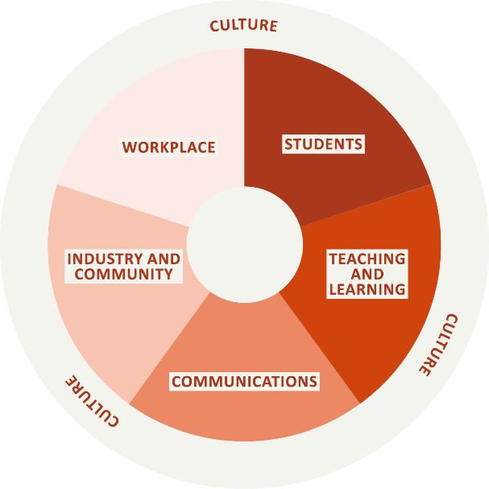

Acknowledgements
Our Watch acknowledges the Traditional Owners of the land across Australia on which we work and live. We pay our respects to Aboriginal and Torres Strait Islander peoples past and present.
Our Watch acknowledges the support of the Victorian Government.

© Our Watch 2021

Who was involved?
Chisholm Institute (Chisholm) is one of Victoria’s public entities providing vocational education and training, funded by the Victorian government, located in Melbourne’s south-east. Chisholm as a government-owned TAFE offers more than 300 certificate, diploma, advanced diploma, bachelor and graduate certificate courses.
Women’s Health in the South East (WHISE) is the regional women’s health service for the Southern Metropolitan Region. WHISE is a not-for-profit organisation that works to improve the health and well-being of women in the region by providing health information and education to governments, organisations, education providers and community groups.
The Family Violence Prevention Activities in Tertiary Education Settings Pilot Project, funded by the Victorian Government’s Office for Family Violence Prevention and Coordination, which enabled four Victorian TAFEs to employ a family violence prevention officer to be actively engaged with the primary prevention of all forms of violence against women. Chisholm was one of the TAFEs to receive this funding.

Why was the partnership needed?
As the lead agency for the health and wellbeing of women in the Southern Metropolitan Region of Melbourne, WHISE is keenly aware of the context in which they operate, and have a sound understanding of the key stakeholders in their locale and the importance of developing strong relationships with these key stakeholders. Chisholm is one of the region’s largest employers; the WHISE CEO approached the CEO of Chisholm to discuss ways to create a mutually valuable partnership.
WHISE was invited to present a session to Community Services course coordinators and students at Chisholm. Once the Family Violence Prevention Officer was established in the role at Chisholm, the partnership was broadened to encompass and support activity across the whole TAFE. A Memorandum of Understanding (MOU) was subsequently scoped, developed and executed by both parties. This MOU sets out the mutually beneficial key objectives, and roles and responsibilities of the two organisations.

What were the objectives?
Both organisations are based and deliver services in the Southern Metropolitan region of Melbourne. The partnership was based upon two key mutually beneficial goals for that region: to enhance the skill and size of the prevention of violence against women workforce in the region; and to lift capacity in gender equality both within the TAFE and within the region’s workforce. The partnership goals are to be primarily achieved through building the capability of the existing workforce through relevant tailored training and workshops, and promoting pathways for individuals to enter into the prevention workforce.
The partnership supports the implementation of recommendations of the Victorian Government Royal Commission into Family Violence, as defined in the Family Violence Reform Rolling Action Plan 2020-2023, and undertakes work to assist Chisholm to implement Victoria’s Gender Equality Act 2020 (Gender Equality Act).

What has the partnership achieved?
Since the partnership has been in place, the two organisations have delivered the following:

Gender equality workshops
A series of tailored workshops were held for key staff at Chisholm and co-facilitated by WHISE and the Family Violence Prevention Officer. The workshops were delivered to the People, Culture and Safety Team staff at Chisholm, upskilling them in the Gender Equality Act and the requirements that Chisholm needs to meet. Chisholm promoted the workshop to employees while WHISE provided subject matter expertise and supported the Family Violence Prevention Officer by enhancing their skills and knowledge in facilitating gender equality workshops. Staff that attended reported an increased understanding of the Gender Equality Act and Chisholm’s obligations under the Act.

Women in trades partnership
Chisholm, WHISE and Tradeswomen Australia formed a partnership to address the issue of sexism and gender inequality in trade. For further details on this training, please refer to the ‘Case study: Women in trades partnership’ at Respect and Equality in TAFE.

Webinar on gendered impact of COVID-19
A webinar was held to explore the gendered impact of the COIVD-19 pandemic. Invitations were distributed internally to staff and externally through Chisholm networks, which included other Victorian TAFEs, the Department of Education and Training, the Office for Family Violence Prevention and Coordination, the Office for Women and other sector stakeholders. The purpose of the webinar was to raise awareness of the gendered impacts of COVID-19, its effects on TAFE and to discuss recovery in TAFE and higher education. The webinar was hosted by Chisholm and featured a panel discussion with the CEO from the state peak organisation for gender equity, Gender Equity Victoria, and WHISE. The recording was distributed to participants following the session and uploaded to the Chisholm staff intranet.

Workforce development forum
An online forum on careers and education pathways for the family violence and gender equity sector was held. Both Chisholm and WHISE networks were invited to attend, as well as local networks such as the integrated family violence network plus representatives from the state government and state-wide services (Family Safety Victoria and Respect Victoria). The forum was hosted by WHISE, in partnership with Chisholm and the Integrated Family Violence Partnerships of both Bayside Peninsula and Southern Melbourne. The goal was to raise awareness about shared workforce development challenges, and to seek feedback from industry and partners in the Southern Metropolitan Region on what actions could be taken to address these challenges. The purpose was to:
- engage partners in the Southern Metropolitan Region to address workforce supply challenges across the family violence sector; and
- explore the benefits of identifying and communicating career and educational pathways for prevention and family violence workforces in the region.
In addition, the forum sought to provide Chisholm and WHISE with an approach to form the Workforce Development Working Group for Southern Metropolitan Melbourne.
The forum attracted 58 registrations, with representatives from the education and training sector, family violence sector, state government, local government and community health. Presentations and breakout sessions were led by Family Safety Victoria, the Regional Integrated Family Violence Partnership, Chisholm and WHISE.
The forum was evaluated utilising data collected pre, during and post the event. Overall, the feedback was highly positive, with participants reporting an increase in knowledge of career and education pathways for the family violence and gender equality workforce. Participants were invited to register their interest in joining the proposed Workforce Development Working Group, and were provided with a report outlining the resulting recommendations and asked to prioritise recommendations for action.

What’s next?
The tailored training to staff on the Gender Equality Act has been highly beneficial. Both WHISE and Chisholm plan to build upon this internal training and deliver further targeted sessions, such as workshops on how to conduct a gender impact assessment.
The forum generated a lot of interest from stakeholders and local services to enhance the family violence workforce in Southern Metropolitan Melbourne. The focus of the Workforce Development Working Group is to action the priority recommendations that came out of the forum on Career Education Pathways. The working group has held its first meeting, developing terms of reference, with membership comprising representatives from WHISE, Chisholm, Family Safety Victoria, Respect Victoria and the local family violence sector.

What were the benefits?
The benefits of the partnership have been numerous for both organisations, including:
- the opportunity to implement mutually beneficial activities collaboratively, allowing the organisations to share resources, skills and networks
- WHISE has skilfully imparted knowledge and expertise in gender equality to the benefit of Chisholm’s workforce
- the partnership has raised Chisholm’s profile in the region, as WHISE has supported Chisholm to connect to regional networks and partnerships, resulting in enhanced relationships with local services
- connecting with key regional networks and services has meant Chisholm has been kept informed of sector changes, and remained up to date with the demands of the industry and best practice
- Chisholm’s courses and certificates related to family violence and gender equality have been promoted to stakeholders both locally and more broadly across Victoria.
Both partners have highlighted the passion and commitment from all members as the real strength in the collaboration, in that both WHISE and Chisholm equally drive actions.

What were the challenges?
Time and resourcing have presented challenges for the partnership. It takes substantial planning to deliver collaborative sessions, with project staff needing to be dedicated in leading the initiatives. The funding to employ the Family Violence Prevention Officer role was a pilot program has overcome the lack of resourcing in TAFE, and partnering with WHISE has meant the planning and delivering of the activities has been able to be shared.
Aligning the work to vocational education and training (VET) policy proves to be a constant challenge. While social reform policy with regard to gender equality and family violence moves forward, its application and implementation through VET requires ongoing negotiation. The collaboration between WHISE and Chisholm has provided an opportunity for both parties to better understand both VET policy and the opportunities that the policy provides to enhance gender equality and the prevention of violence against women. This involves translating and brokering the benefits of equity and prevention into the benefits that TAFE delivers – that is, to industry, workers, job seekers and the economy. Employing values-based messaging that is in keeping with the goals of TAFE is key to doing this, as is ensuring that the outcomes of equity and prevention of violence are aligned to the experience of TAFE workers and management.

