Changing the landscape: A national resource to prevent violence against women and girls with disabilities
Summary
Our Watch and Women with Disabilities Victoria

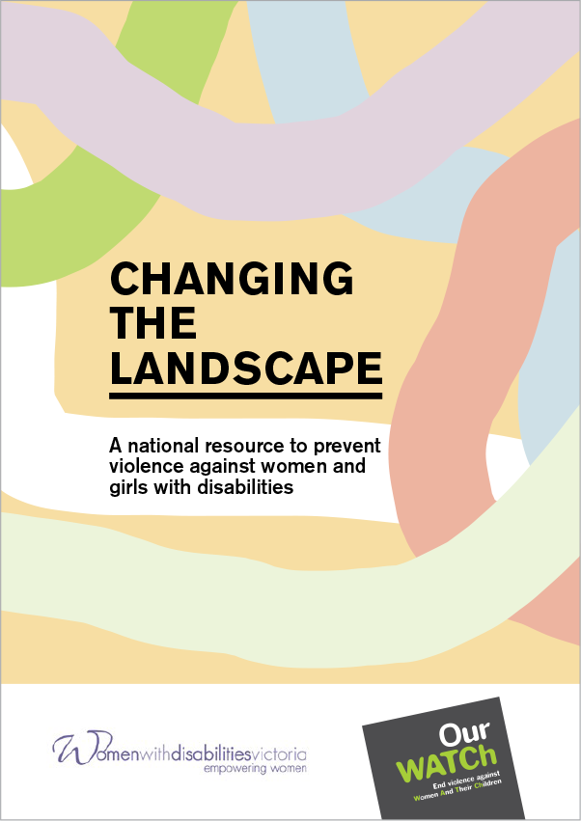
This is a summary of Changing the landscape: A national resource to prevent violence against women and girls with disabilities. The full document provides a comprehensive description of the drivers of violence against women and girls with disabilities, the essential actions to prevent this violence, and the principles that should guide this prevention work. It also includes extensive references to support the points made in this summary document.
The full document can be found at www.ourwatch.org.au/resource/changing-the-landscape.
This project was conducted by Our Watch and Women with Disabilities Victoria.
© Our Watch 2022
GPO Box 24229
Melbourne Vic 3001
www.ourwatch.org.au

Introduction
Violence against women and girls with disabilities is a prevalent, serious and preventable violation of human rights. Women and girls with disabilities experience all the forms of violence experienced by women and girls without disabilities and by other people with disabilities, with some of these forms of violence normalised or legally sanctioned in society. However, women and girls with disabilities experience violence, abuse and neglect at much higher rates, over longer periods of time, and perpetrated by more people than men with disabilities or people without disabilities.
For women and girls with disabilities who experience other forms of oppression based on factors such as race or age, experiences of violence can be compounded further.
To stop violence against women and girls with disabilities before it starts, it is critical to identify and address the underlying drivers of this violence; or, in other words, the factors that lead to violence and enable it to continue. Changing the landscape: A national resource to prevent violence against women and girls with disabilities identifies the underlying drivers of violence against women and girls with disabilities as specific intersecting expressions of gender inequality and ableism.
Addressing the drivers of violence is not only a means to ending violence against women and girls with disabilities, but will help to build a society where women and girls with disabilities are valued and are able to fully realise their human rights on an equal basis with all other people.

Purpose of Changing the landscape
Changing the landscape complements but also extends the evidence and guidance in Change the story: A shared framework for the primary prevention of violence against women in Australia. Change the story brings together international research and nationwide experience on what drives violence against women and what is needed to prevent this violence.
Changing the landscape has been developed to:
- build and deepen the understanding of violence against women and girls with disabilities and its dynamics and impacts
- offer a conceptual model that explains the underlying and intersecting drivers of this violence
- provide a set of essential actions that address the underlying drivers of violence against women and girls with disabilities at all levels of society
- provide supporting actions to address the reinforcing factors of violence against women and girls with disabilities
- offer principles for prevention that guide the way in which the essential and supporting actions should be implemented.
Our Watch and Women with Disabilities Victoria believe that by shifting sexist and ableist attitudes and structures, we can stop this violence at the start. That is why we called this resource, ‘Changing the landscape’. Many of the women we consulted with about what to title this resource highlighted the array of factors right across society that need to shift in order to change these underlying drivers of violence against women and girls with disabilities. Embracing the input from those consulted, the resource is a positive, future-focused guide to changing the systemic, structural and cultural ‘landscape’ in order to prevent this violence.

What drives violence against women and girls with disabilities?
Research and consultation point to two consistent intersecting drivers of violence against women and girls with disabilities: specific expressions of gender inequality and ableism. These include:

Gender inequality

Gendered drivers
- Condoning of violence against women.
- Men’s control of decision-making and limits to women’s independence in public and private life.
- Rigid gender stereotyping and dominant forms of masculinity.
- Male peer relations and cultures of masculinity that emphasise aggression, dominance and control.

Ableism

Ableist drivers
- Negative stereotypes about people with disabilities.
- Accepting or normalising violence, disrespect and discrimination against people with disabilities.
- Controlling people with disabilities’ decision-making, and limiting independence.
- Social segregation and exclusion of people with disabilities.
Further, other forms of oppression such as racism, classism, homophobia and transphobia can intersect with gender inequality and ableism to influence the prevalence, nature and dynamics of violence perpetrated against women and girls with disabilities.
These drivers are demonstrated visually in Figure 1 on the following page.
Changing the landscape discusses the factors that make up each driver, and how they interact.

Figure 1: Conceptual model of the intersecting drivers of violence against women and girls with disabilities
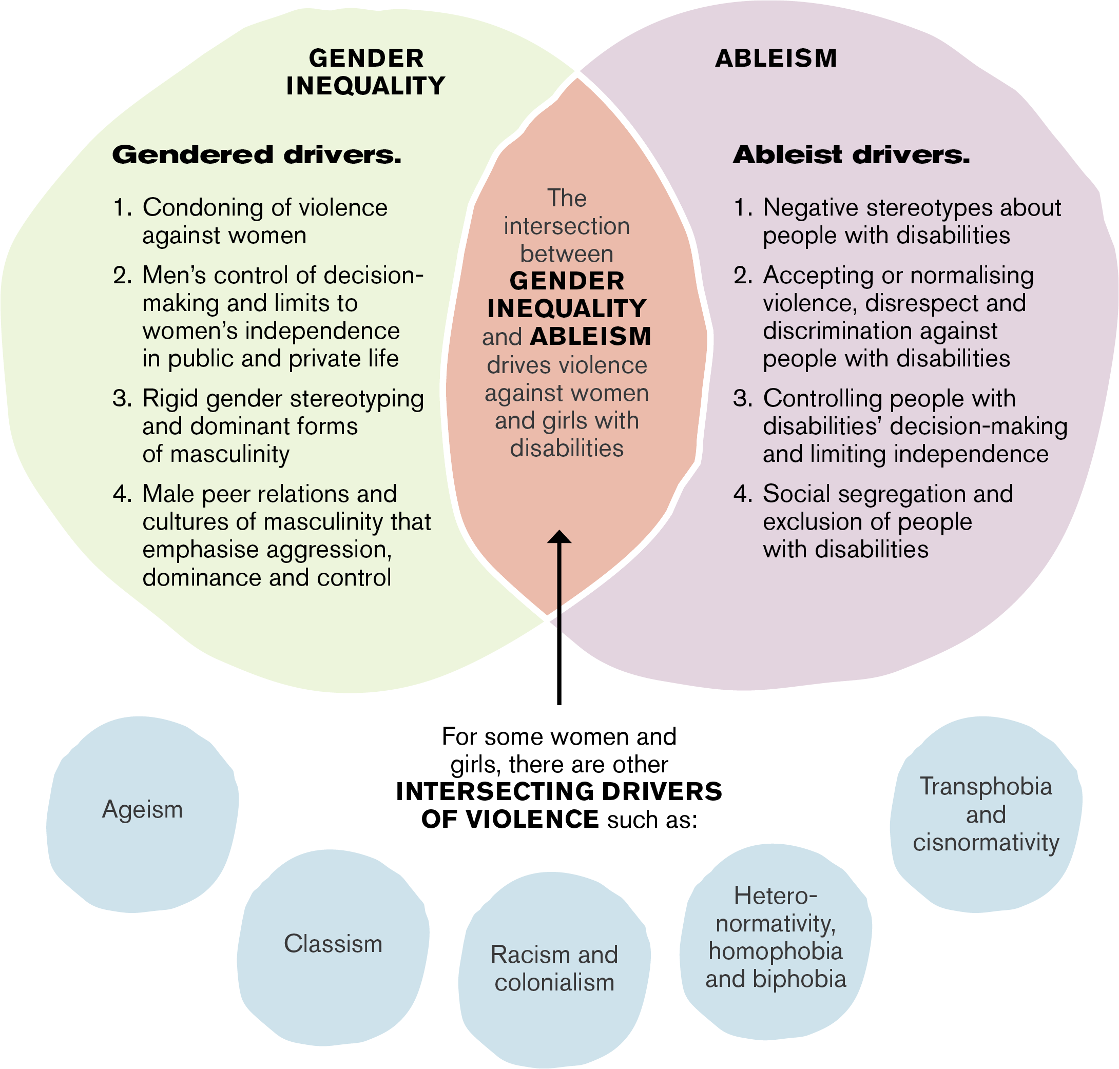
Refer to the alternative text for Figure 1 on page 9.

Essential prevention actions
To prevent violence against women and girls with disabilities from happening in the first place, actions are needed that directly address the underlying drivers of the violence. These six actions are:

Action 1
Address the underlying social context that gives rise to violence against women and girls with disabilities.

Action 2
Challenge the acceptance and normalisation of violence against women and girls with disabilities.

Action 3
Improve attitudes towards women and girls with disabilities by challenging ableist and sexist stereotypes.

Action 4
Promote the inclusion of women and girls with disabilities in all aspects of life.

Action 5
Promote women and girls with disabilities’ independence, agency and participation in leadership and decision-making.

Action 6
Engage men and boys to challenge controlling, dominant and aggressive forms of masculinity.

Principles for prevention
To ensure that work that aims to prevent violence against women and girls with disabilities is effective, meaningful, safe and respectful, it should be guided by the following principles:
- Centre the input of women and girls with disabilities.
- Ensure autonomy, community ownership and control.
- Co-design.
- Use a strengths-based approach.
- Build partnerships and opportunities for collaboration.
- Be respectful and authentic.
- Ensure the physical, emotional and cultural safety of women and girls with disabilities.
- Ensure accessibility and inclusion.
- Ensure prevention work is informed by critical frameworks.
- Contribute to the evidence base.

Alternative text

Page 6, Figure 1: Conceptual model of the intersecting drivers of violence against women and girls with disabilities
Infographic of a conceptual model, which shows that the intersection between gender inequality and ableism drives violence against women and girls with disabilities.
Gender inequality is expressed through the gendered drivers:
- Condoning of violence against women.
- Men’s control of decision-making and limits to women’s independence in public and private life.
- Rigid gender stereotyping and dominant forms of masculinity.
- Male peer relations and cultures of masculinity that emphasise aggression, dominance and control.
Ableism is expressed through the ableist drivers:
- Negative stereotypes about people with disabilities.
- Accepting or normalising violence, disrespect and discrimination against people with disabilities.
- Controlling people with disabilities’ decision-making and limiting independence.
- Social segregation and exclusion of people with disabilities.
For some women and girls, there are other intersecting drivers of violence such as:
- ageism
- classism
- racism and colonialism
- heteronormativity, homophobia and biphobia
- transphobia and cisnormativity.

